Student’s name | …………………………………………………….…… | Grade | 2
Subject | Computer | Week No. | 3
Lesson Title | Manage Files and Folders | Unit
Worksheet No. ( 3 ) (Answer)

write the correct name of each part.


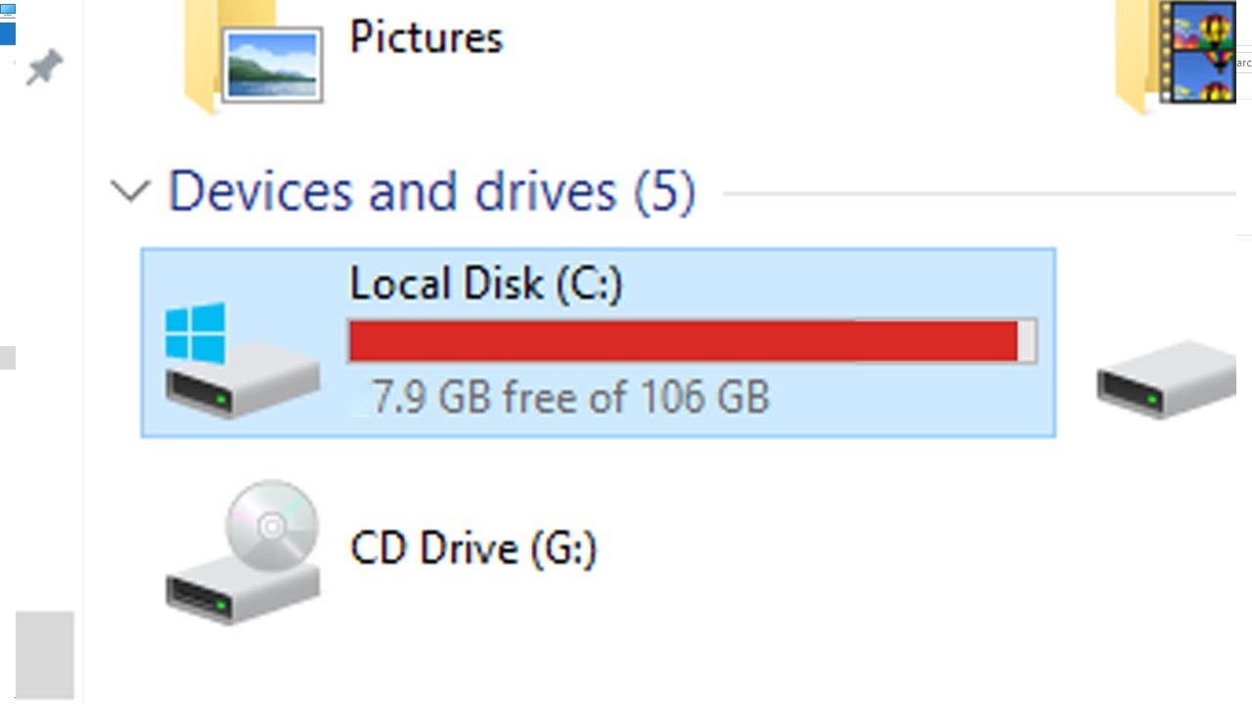
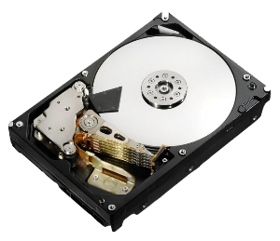
Good Luck

Hard Disk

C: Drive
File
Folder
C: Drive
Folder
Hard Disk
File

